**Model Development Phase Template**

|  |  |
| --- | --- |
| Date | 11-03-2025 |
| Team ID | 740047 |
| Project Title | AI-POWERED VEHICLE DAMAGE ASSESSMENT FOR COST ESTIMATION AND INSURANCE CLAIMS. |
| Maximum Marks | 4 Marks |

**Initial Model Training Code, Model Validation and Evaluation Report**

The initial model training code will be showcased in the future through a screenshot.

**Initial Model Training Code:**

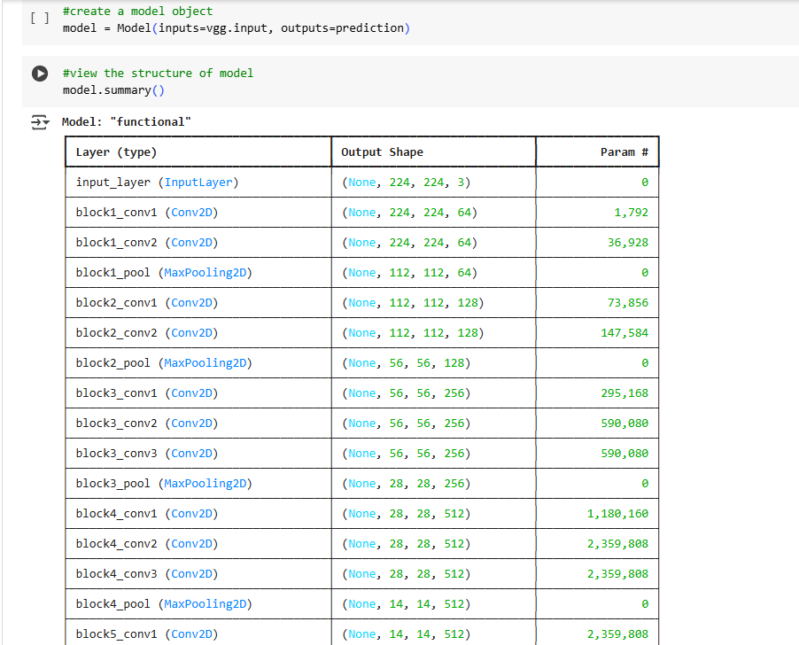

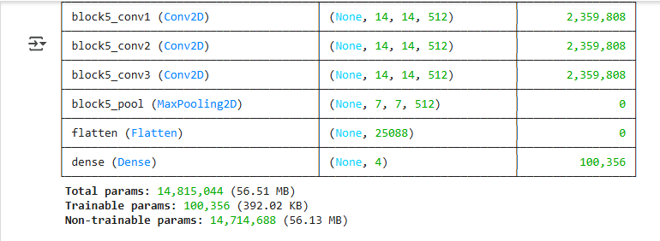

**Compiling the model**

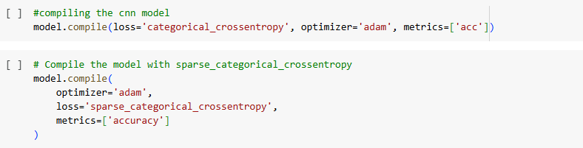

**Fitting the model**

